* **Activity 10:**

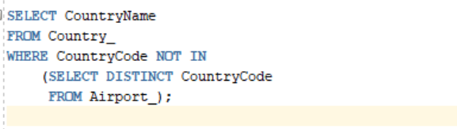Null Values in a Multiple-Row Subquery

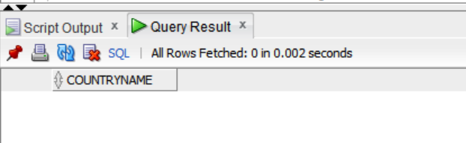OUTPUT: